Date:- 28.02.2022
Latest Announcements

KeyShot 11 Release
KeyShot 11 will be released on February 8th on a subscription license basis!

What’s New in KeyShot 11 ?

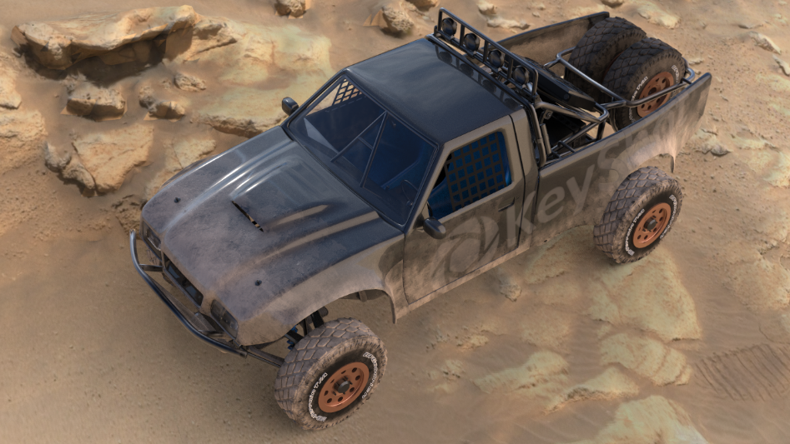
3D Paint Tool
Keyshot's new 3D paint tool gives users the ability to customize surface
finishes and textures by directly painting or stamping on the surface of the
model.

Physics Simulation
Physics simulation will allow users to record the physics & collision detection
and apply it as a Keyframe animation.

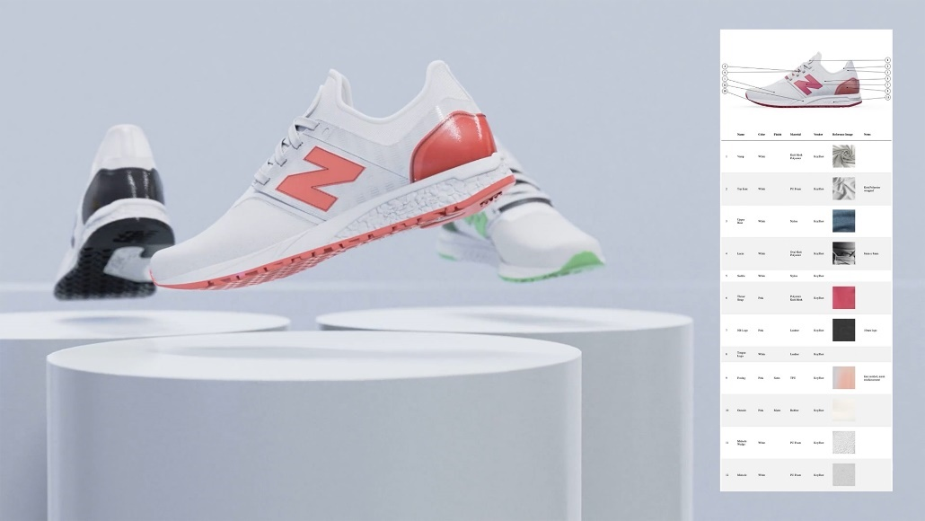
Color, Material, Finish (CMF) Tool Customers can use the CMF Tool in KeyShot 11 to output callouts on their
renders. Users can identify material descriptions, material costs, texture finish,etc..

FBX Deformable Animations

KeyShot users can now import FBX deformable animations. Previously, only
Alembic (.abc) deformable animations could be imported into KeyShot.
FBX import includes FBX files with .mc/.mcx cache files, used by CLO,
VStitcher and Maya for export simulations and also FBX files with rigged
animations.

Web Viewer
Customers with KeyShot 11 and KeyShot Web ( Subscription Only) can now
upload KeyShot files to the new KeyShot Web Viewer, so they can interact and
share scenes online with others from any device, anywhere.

